

LIBRARY MANAGEMENT SYSTEM
Software Requirement Specification

– Hanoi, March 2026 –
Table of Contents
I. Record of Changes 3
II. Software Requirement Specification 4
1. Product Overview 4
2. User Requirements 4
2.1 Actors 4
2.2 Use Cases 5
3. Software Features 7
3.1 Functional Overview 7
3.2 <<Authentication and Profile>> 12
3.3 <<Book Catalog and Search>> 14
3.4 <<Borrow Request Management>> 17
3.5 <<Borrow Processing for Librarian>> 31
3.6 <<Fine Management>> 35
3.7 <<Catalog Administration>> 39

I. Record of Changes
Date | A*  M, D | In charge | Change Description
20/03/2026 | A |  | Initial SRS document
*A - Added M - Modified D - Deleted

II. Software Requirement Specification

1. Product Overview
The Library Management System is a web-based information system that supports daily library operations for both borrowers and librarians. The solution centralizes book catalog maintenance, borrowing workflows, return tracking, fine handling, and dashboard visibility within a single integrated platform.
The system is designed for an educational library context where books must be searchable, borrowing requests must be controlled, and librarian actions must directly affect inventory status. A role-based approach separates end-user functions from operational management functions.
From the source context, the solution uses a single-page React frontend and an ASP.NET Core Web API backend with Entity Framework Core and SQL Server. The overall architecture follows a controller-service-data access flow on the backend and route-based role separation on the frontend.

2. User Requirements

2.1 Actors

# | Actor | Description
1 | Borrower | Regular member who browses books, sends borrow requests, monitors current borrows, and reviews personal fines.
2 | Librarian | Operational staff who manages books, authors, categories, reviews borrow requests, records returns, and monitors dashboard statistics.

2.2 Use Cases
The identified use cases are summarized below. A visual use-case diagram is not embedded in this version because the source package provided textual context only; however, the functional grouping and actors can be directly inferred from the implemented routes and controllers.
ID | Use Case | Primary Actor | Brief Description
UC-01 | Login and signup | All users | Authenticate a user and issue role-based access.
UC-02 | Manage profile | Borrower / Librarian | View and update personal profile information.
UC-03 | Browse and search books | All users | Search catalog, view details, and review availability.
UC-04 | Request borrow | Borrower | Submit a new borrowing request with due date.
UC-05 | View current borrowed items | Borrower | Track request status, due date, and renew or cancel where allowed.
UC-06 | Process borrow requests | Librarian | Approve, reject, or complete returns.
UC-07 | Manage fines | Borrower / Librarian | Display, create, and update fine status.
UC-08 | Manage catalog masters | Librarian | Maintain books, authors, and categories.

3. Software Features

3.1 Functional Overview
Functionally, the system is organized into authentication, catalog discovery, borrowing lifecycle, librarian processing, fine handling, and catalog administration. Inventory counts and statuses are critical control points because they affect whether requests may proceed and whether penalties should be generated.

3.1.1 Functional Modules
No. | Module | Main Actor | Core Purpose
1 | Authentication & Profile | All users | Registration, login, token-based access, and profile maintenance.
2 | Book Catalog & Search | All users | View books, filter results, and inspect detailed book information.
3 | Borrower Borrowing | Borrower | Create borrow requests and monitor current borrowing lifecycle.
4 | Librarian Borrow Processing | Librarian | Approve, reject, and complete return actions while updating stock.
5 | Fine Management | Borrower / Librarian | Track overdue penalties and mark fines as paid.
6 | Catalog Administration | Librarian | Manage books, authors, categories, images, and soft deletion.

3.1.2 Business Flows
Authentication flow: The user submits credentials. The API validates the account, generates a JWT containing role information, and the frontend stores the token and redirects to the appropriate role-specific area.
Borrow request flow: A borrower opens a book detail page, chooses a due date, and submits a request. The request is stored with Pending status and remains waiting for librarian action.
Borrow approval flow: The librarian reviews pending requests, verifies stock, and approves a request. Once approved, the book's available quantity is reduced by one and the request becomes active.
Return and fine flow: When the item is returned, the librarian records the return. Available quantity is restored. If the return date is later than the due date, the system creates a fine record based on the late period and configured business logic inferred from the code summary.
Catalog maintenance flow: The librarian creates, edits, or soft deletes books, authors, and categories. Validation ensures inventory consistency and preserves historical references using IsDeleted flags.

3.1.3 Screen and Route Overview
No. | Screen / Route | Actor | Purpose
1 | /login, /signup | All users | Access the system and create accounts.
2 | /profile | Borrower / Librarian | Review and edit profile information.
3 | /books | All users | Browse the full catalog with search and filters.
4 | /books/:id | All users | View book details and initiate borrow action when eligible.
5 | /my-borrowed | Borrower | Track submitted and active borrow requests.
6 | /my-fines | Borrower | Review personal fines and fine status.
7 | /librarian/borrowers | Librarian | Review borrow requests and process returns.
8 | /librarian/fines | Librarian | View and update fines.
9 | /librarian/books, /authors, /categories | Librarian | Administer catalog master data.

3.1.4 Entity Relationship Summary
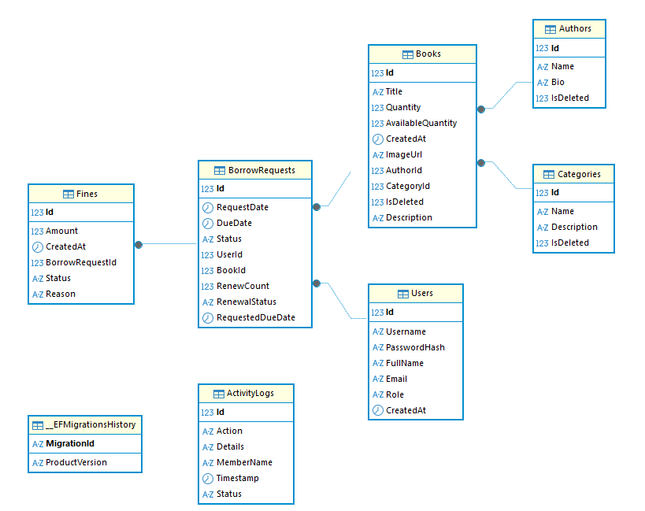

The system revolves around six principal entities: User, Book, Author, Category, BorrowRequest, and Fine. User and Book are the two entities most central to the borrowing lifecycle. BorrowRequest acts as the transaction entity linking borrowers to books, while Fine depends on overdue or penalty conditions. Book references Author and Category, and soft-delete flags preserve lookup consistency.
Entity | Key Attributes | Relationships
User | Id, Username, PasswordHash, FullName, Email, Role, CreatedAt | One user can have many borrow requests.
Book | Id, Title, Quantity, AvailableQuantity, Description, ImageUrl, AuthorId, CategoryId, IsDeleted | Each book belongs to one author and one category; one book can have many borrow requests.
Author | Id, Name, Bio, IsDeleted | One author can be linked to many books.
Category | Id, Name, Description, IsDeleted | One category can classify many books.
BorrowRequest | Id, UserId, BookId, RequestDate, DueDate, Status, RenewCount | Links one user and one book; can have fine records.
Fine | Id, BorrowRequestId, Amount, Status, Reason, CreatedAt | Belongs to a borrow request.

3.1.5 Entity Details
User Profile: Stores account credentials, role information, and personal information used for authentication and profile display.
Book: Represents a library item with bibliographic details, stock information, descriptive content, and an optional image.
Author: Represents the author master record used by books for organization and filtering.
Category: Represents the classification or genre used to group books in the catalog.
BorrowRequest: Represents each borrowing transaction, including request state and due-date control.
Fine: Represents a monetary penalty resulting from an overdue or other enforced rule.

3.2 <<Authentication and Profile>>

3.2.1 <<FID-01 - Function Login and Profile Management>>
This function group allows users to register, log in, and manage personal profile information. Access after authentication depends on the role embedded in the issued token.

3.2.1.1 Screen Definition
Item | Description
Main routes | /login, /signup, /profile
Primary actor | All users
Input data | Username, password, full name, email, role on sign up; editable profile information on profile screen
Output | JWT token, authenticated session, and displayed profile data
Related backend components | AuthController, AuthService
Related frontend components | Login.jsx, Signup.jsx, ProfileEdit.jsx

3.2.1.2 Use Case Description
Field | Details
Actors | Borrower, Librarian
Trigger | User submits login credentials or profile update
Pre-conditions | The user account exists for login; user is authenticated for profile update
Post-conditions | Valid login creates authenticated session; profile update persists new values
Normal flow | 1) User enters credentials.  2) System validates credentials.  3) System returns token and profile information.  4) Frontend redirects user based on role.  5) Authenticated user may open profile page and submit edits.
Alternative flows
- Invalid credentials are rejected and access is not granted.
- Unauthorized users cannot open protected profile routes.
- If token is absent or expired, the frontend must force the user back to a login path.
Business Rules
- Role-based menus and routes must be enforced.
- Password handling must use hashing rather than raw password storage.
- Profile update is limited to permitted personal fields such as full name and email.

3.3 <<Book Catalog and Search>>

3.3.1 <<FID-02 - Function Book Browsing and Search>>
This function allows users to view the library catalog, search for books, filter results, and open detailed pages showing availability and bibliographic data.

3.3.1.1 Screen Definition
Item | Description
Main routes | /books, /books/:id
Primary actor | All users
Input data | Search keyword, category filter, sort field, pagination parameters
Output | Book list, book details, availability status, and cover image if available
Related backend components | BooksController, BookService
Related frontend components | BookList.jsx, BookDetails.jsx

3.3.1.2 Use Case Description
Field | Details
Actors | Anonymous visitor, Borrower, Librarian
Trigger | User opens catalog page or submits a search/filter query
Pre-conditions | Books exist in catalog; soft-deleted data should not appear in public results
Post-conditions | Filtered or paginated results are shown; selected book detail can be opened
Normal flow | 1) User opens the catalog.  2) System loads books with paging.  3) User applies filters or search text.  4) System refreshes result list.  5) User opens a book detail page.
Alternative flows
- If no matching books are found, the page shows an empty state.
- If the user is not logged in, the Borrow action must not proceed beyond public browsing.
- Unavailable books may still be viewable but must clearly indicate stock status.
Business Rules
- Catalog view is public for read-only access.
- Pagination should be applied on the backend for performance.
- Borrow initiation requires authenticated user access.

3.4 <<Borrow Request Management>>

3.4.1 <<FID-03 - Function Request Borrow and Track Personal Borrows>>
This function enables borrowers to submit borrow requests, monitor active requests, and manage their personal borrowing status from the borrower area.

3.4.1.1 Screen Definition
Item | Description
Main routes | /books/:id, /my-borrowed
Primary actor | Borrower
Input data | Due date for request, request action, optional renew action where available
Output | BorrowRequest record with current status
Related backend components | BorrowController, BorrowService
Related frontend components | BookDetails.jsx, MyBorrowed.jsx

3.4.1.2 Use Case Description
Field | Details
Actors | Borrower
Trigger | Borrower clicks request-to-borrow from a book detail page
Pre-conditions | User is logged in with Borrower role; requested due date is valid; borrowing limit is not exceeded
Post-conditions | Pending borrow request is created and visible in the user's personal borrow list
Normal flow | 1) Borrower opens book detail.  2) Borrower chooses a due date.  3) System validates eligibility.  4) System creates a Pending request.  5) Borrower checks the request status in My Borrowed.
Alternative flows
- If the due date is invalid or not in the future, the request must be rejected.
- If the borrower already holds the maximum allowed approved books, the request is not created.
- If the project version enables renew, the system may extend due date and increment RenewCount based on rule checks.
Business Rules
- A borrower may hold at most three approved books at one time, based on the provided context.
- Due date must be later than the current date.
- Pending, Approved, Rejected, Returned, and Cancelled are valid borrow statuses mentioned in the code summary.

3.5 <<Borrow Processing for Librarian>>

3.5.1 <<FID-04 - Function Approve, Reject, and Return Borrow Requests>>
This function allows librarians to review borrower requests and perform operational actions that directly affect the inventory and transaction lifecycle.

3.5.1.1 Screen Definition
Item | Description
Main route | /librarian/borrowers
Primary actor | Librarian
Input data | Borrow request identifier and action type
Output | Updated borrow status and updated available quantity
Related backend components | BorrowController, BorrowService
Related frontend components | LibrarianBorrowers.jsx

3.5.1.2 Use Case Description
Field | Details
Actors | Librarian
Trigger | Librarian opens the request management screen and selects an action
Pre-conditions | User has Librarian role; target request exists; stock remains available for approval
Post-conditions | Request status is updated and related stock values are synchronized
Normal flow | 1) Librarian opens borrow management.  2) System loads pending and active requests.  3) Librarian chooses Approve, Reject, or Return.  4) System validates the action.  5) System updates status and stock.  6) If return is overdue, a fine is generated.
Alternative flows
- Approval must fail if no available quantity remains.
- Return processing may produce a fine if the due date has passed.
- Requests already finalized should not be processed again with conflicting actions.
Business Rules
- Approving a request decreases AvailableQuantity by one.
- Returning a book increases AvailableQuantity by one.
- Late return triggers fine calculation according to overdue duration and applicable fine logic.

3.6 <<Fine Management>>

3.6.1 <<FID-05 - Function Fine Tracking and Payment Status Update>>
This function manages overdue penalties. Borrowers can review their fines, while librarians can inspect and update fine settlement status.

3.6.1.1 Screen Definition
Item | Description
Main routes | /my-fines, /librarian/fines
Primary actor | Borrower, Librarian
Input data | Fine amount, reason, status update
Output | Displayed fine records and updated payment status
Related backend components | FinesController, FineService
Related frontend components | MyFines.jsx and librarian fine pages

3.6.1.2 Use Case Description
Field | Details
Actors | Borrower, Librarian
Trigger | A fine is generated during overdue return processing or reviewed from a fine screen
Pre-conditions | Associated borrow request exists and meets overdue condition for generation
Post-conditions | Fine record is stored and may later be marked as paid
Normal flow | 1) System detects overdue return.  2) System creates fine record.  3) Borrower or librarian opens fine list.  4) Librarian updates status when settlement is confirmed.
Alternative flows
- If no fine exists for a borrow request, the user sees no penalty item.
- Status updates should be limited to valid values.
- The document context does not show external payment gateway integration, so settlement is assumed to be internal/manual.
Business Rules
- Standard fine rate inferred from context is 5,000 VND per late day.
- Fine statuses are Unpaid and Paid.
- Fine creation should maintain reference to the related borrow request.

3.7 <<Catalog Administration>>

3.7.1 <<FID-06 - Function Manage Books, Authors, and Categories>>
This function allows librarians to maintain master data for the library catalog, including CRUD-style administration, image handling, and soft deletion.

3.7.1.1 Screen Definition
Item | Description
Main routes | /librarian/books, /librarian/authors, /librarian/categories
Primary actor | Librarian
Input data | Title, author, category, quantity, description, image file, bio, category description
Output | Created or updated master records
Related backend components | BooksController, AuthorsController, CategoriesController
Related frontend components | Librarian catalog management pages

3.7.1.2 Use Case Description
Field | Details
Actors | Librarian
Trigger | Librarian opens an admin page and chooses create, edit, or delete
Pre-conditions | User has Librarian role; referenced author and category exist for book operations
Post-conditions | Master data is created, edited, or soft-deleted while preserving consistency
Normal flow | 1) Librarian opens management page.  2) Librarian enters data in form or popup.  3) System validates fields and relationships.  4) Data is saved.  5) Lists are refreshed with latest values.
Alternative flows
- Quantity updates must not conflict with currently borrowed stock.
- Invalid image formats must be rejected.
- Soft-deleted records should stop appearing in active lists but still preserve historical references.
Business Rules
- Accepted image types include standard formats such as .jpg, .png, and .webp.
- Books, authors, and categories use IsDeleted rather than hard deletion according to the provided context.
- Validation must prevent reducing quantity below the number of books currently on loan.

